LAB-1 Report

Sirisha Pakalapati

Id no:16161825

UML DIAGRAMS:

CLASS DIAGRAM: The below is the UML Class diagram of Home security system. Here in the class diagram I have drawn there are nine classes: Controller is the class which controls the all other classes. All the entry sensors, smoke sensors, temperature sensors, flood sensor represent their attributes and their operations.

H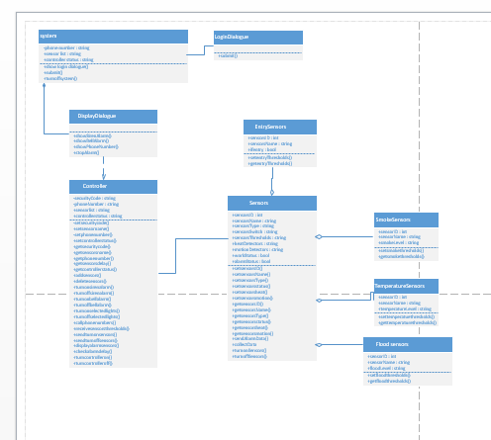

SEQUENCE DIAGRAM:

The below is the sequence diagram for how the system responds to the alarm being triggered. Here are the sequence of steps where I have shown when an intruder enters into the home, the alarm responds.

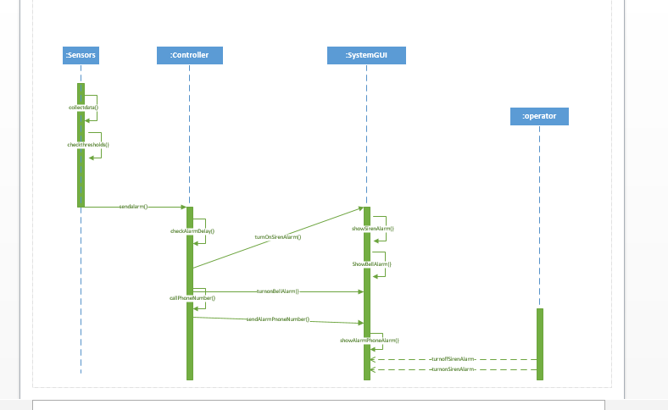

2) The following is the sequence diagram the alarm to be turned off.

The below is the sequence diagram when the owner gives the reply to the controller for turning of the alarm.

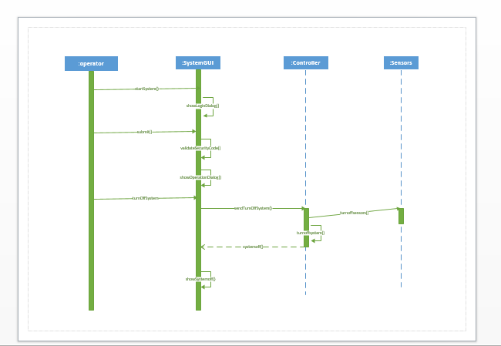

Th